S-100 – Part 10b

GML Data Format

Page intentionally left blank

Contents

10b-1 Scope 1
10b-2 Conformance 1
10b-3 References 1
10b-4 Introduction 2
10b-5 General concepts 2
10b-6 Notation and diagram conventions 2
10b-7 Components and relationships to standards 2
10b-7.1 Use of profile 3
10b-7.2 Interpretations 3
10b-8 Profile for feature data 3
10b-8.1 Feature and information types 3
10b-8.2 Feature collections 4
10b-8.3 Associations 4
10b-8.3.1 Association classes 4
10b-8.4 Data types 5
10b-8.4.1 Primitive types 5
10b-8.4.2 Value types 5
10b-8.4.3 Other data types 5
10b-8.5 Spatial types 6
10b-8.5.1 Geometric primitives 6
10b-8.5.2 Curve Interpolation 6
10b-8.5.3 Geometric complex, geometric composites, and geometric aggregates 6
10b-8.5.4 Inline and by-reference encoding 7
10b-8.5.5 Envelope 7
10b-8.6 Unsupported GML functionality 7
10b-8.7 Compliance levels 7
10b-9 S-100 base schema for feature data 8
10b-9.1 Introduction 8
10b-9.2 Features 8
10b-9.3 Information types 9
10b-9.4 Spatial types 9
10b-9.4.1 Inline and referenced geometry 10
10b-9.4.2 Spatial types defined in base schema 10
10b-9.5 Associations 10
10b-9.5.1 Generic tags for associations 12
10b-9.5.2 Role name as property element 13
10b-9.6 Dataset general information 14
10b-9.6.1 Dataset identification 14
10b-9.6.2 Dataset structure information 15
10b-9.7 Feature object identifier 17
10b-9.8 Coordinate Reference System 18
10b-9.9 Dataset structure definition 18
10b-9.9.1 Dataset metadata 18
10b-10 Constraints and validation 18
10b-11 Dataset level metadata and integrity checks 19
10b-12 Schema locations and namespaces 19
10b-13 Divergences from common GML practices 19
10b-14 Conventions for GML datasets 19
Appendix 10b-A Application Schema (informative) 21
10b-A-1. Example of a GML application schema for an S-100-based data product 21
Appendix 10b-B 25
Use of Profile in GML Application Dataset 25
(informative) 25
10b-B-1. Introduction 25
10b-B-2. Dataset structure in GML application schema 25
10b-B-3. Dataset examples in XML/GML 25

Page intentionally left blank

Scope
This Part specifies a profile of GML meant to be used as a basis for the development of GML application schemas for S-100 data products. The GML application schema for each data product defines a file format for the machine-to-machine exchange of information structured in conformance with the application schema for the data product, as defined in the appropriate product specification.
The scope of this Part includes:
- Feature and information type data conforming to the S-100 General Feature Model defined in Part 3, encoded using GML (ISO 19136), and structured as datasets (identifiable collections of data).
- Guidance for use of the schemas in application schemas for data products.
The following are outside scope:
- A format for updates to datasets.
- Interchange by means other than datasets encapsulated as files, such as Web Feature Service (WFS), other Web services, email, etc.
- Information not encapsulated using GML, such as feature catalogues, exchange set metadata, portrayal catalogues, and support files in other XML formats.
- Tools for developing GML application schemas for data products.
- Design and programming of software for processing GML data.
- Gridded and coverage data.

Conformance
The profile described in this Part conforms to the requirements for GML profiles described in ISO 19136.

References
ISO 19106:2003, Geographic information – Profiles.
ISO 19107:2003, Geographic information – Spatial schema.
ISO 19111:2007, Spatial referencing by coordinates (coordinate reference systems).
ISO 19118:2005, Geographic information – Encoding.
ISO 19123:2005, Schema for coverage geometry and functions.
ISO 19136:2007, Geographic information – Geography Markup Language.
ISO 19136-2:2015, Geographic information – Geography Markup Language.
ISO/TS 19139, Geographic information – Metadata – XML schema implementation.
ISO/IEC 19757-3, Information technology – Document Schema Definition Languages (DSDL) – Part 3: Rule-based validation – Schematron.
IETF RFC 2396, Uniform Resource Identifiers (URI): Generic Syntax.
IETF RFC 3986, Uniform Resource Identifiers (URI): Generic Syntax.
W3C XLink, XML Linking Language (XLink) Version 1.0, W3C Recommendation.
W3C XML Namespaces, Namespaces in XML, W3C Recommendation.
W3C XML, Extensible Markup Language (XML) 1.0, W3C Recommendation.
W3C XML Schema Part 1, Structures, W3C Recommendation.
W3C XML Schema Part 2, Datatypes, W3C Recommendation.
LEIRI, Legacy Extended IRIs for XML Resoure Identification, W3C Working Group Note 3. URL: http://www.w3.org/TR/leiri.

Introduction
The S-100 GML profile defines the core GML components that shall be used in GML encodings for S-100 data products. This profile defines a restricted subset of XML and GML types that excludes GML features not required by S-100 GML datasets. This profile of GML is contained in a single file and reduces the complexity of the full GML encoding to a more manageable level A separate XML schema defines common elements and types needed for all S-100 datasets encoding feature-based information.

General concepts
A GML application schema is an XML schema that conforms to the rules for application schemas given in the GML specification (ISO 19136).
A GML document is an XML document with a root element conforming to the rules for GML data specified in the GML specification (ISO 19136). Specifically, in the context of S-100 this means the root element must be a GML AbstractFeature or Dictionary element, or in a substitution group of any of these elements.
The terms “GML application schema” and “application schema” as used in this Part mean respectively an XML schema and a conceptual schema. The former may be an XSD file conforming to the XML schema rules, the latter a UML diagram.
These terms and definitions conform to ISO 19101 and ISO 19136. Complete definitions are given in ISO 19101 and ISO 19136, and are reproduced in Annex A.

Notation and diagram conventions
Diagram element | Meaning
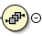 or 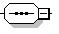 | XML Schema <sequence>
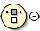 or 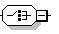 | XML Schema <choice>
 | XML schema multiplicity constraints (here, ”0” and ”unbounded”)

Components and relationships to standards
The GML data format for S-100 consists of the following components, realized as separate XML schemas:
- An XML schema that defines a GML profile (“Profile”). This is a restricted subset of types and elements (“XML constructs”) defined in the GML 3.2.1 schemas. XML constructs not needed for S-100 data products are excluded.
- An XML schema defining additional XML constructs (“S100base”). This schema uses the GML profile schema. The constructs defined in this schema are expected to be needed in order for a product specification conforming to the S-100 standard to define a format for datasets.
The figure below illustrates the dependency relationships. The GML encoding standard (ISO 19136:2007) provides an implementation schema (XML Schema) for the ISO 19100 conceptual schemas. The S-100 GML profile is a subset of the constructs defined by the GML implementation schema. S-100 common elements are defined in a common elements XML schema conforming to the profile. GML formats for specific data products use the constructs in the common elements schema in defining XML types and elements corresponding to feature and information types defined by the relevant Product Specification. A dataset is an XML file conforming to the GML data format (GML application schema).
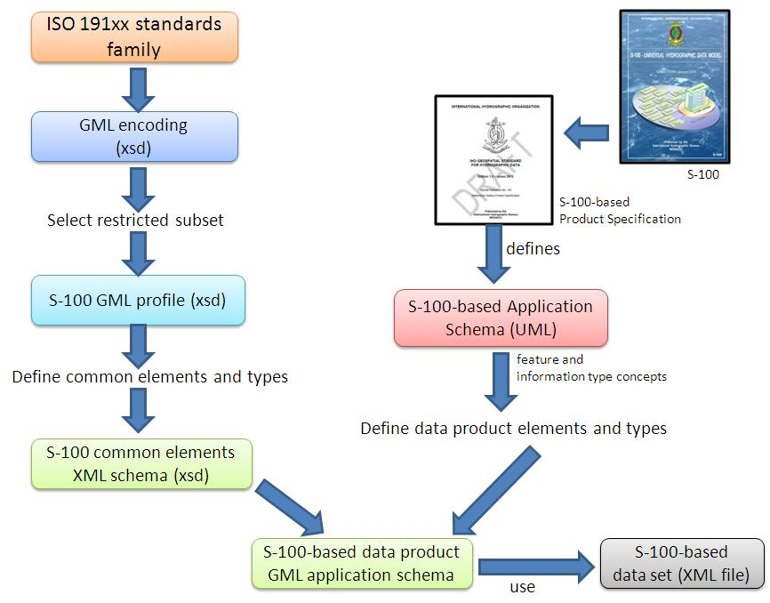
Figure 10b-1 – Derivation of profile and its use by a data product

Use of profile
The typical use of the profile is to define a format for GML files encapsulating datasets packaged as computer files.
Formats for modes of exchange other than datasets are not required to use these schemas.
The S-100 GML Profile has been defined to support validation and an application schema may import the GML 3.2.1 schemas or replace the <import> statement in the common elements with an <import> of the GML 3.2.1 schemas. To enable validation engines to understand that the S-100-based Application Schema adheres to a profile, the S-100 GML Profile must be declared within the schema. This allows the validation engine to select this schema instead of the GML 3.2.1 schema to validate the data against.

Interpretations
The schema components of the GML profile which are part of the “gml” namespace are to be interpreted in conformance with GML as defined by ISO 19136, with the exceptions below.
- ”Linear” curve interpolation type in datasets using a geographic CRS shall be interpreted as loxodromic interpolation.

Profile for feature data

Feature and information types
The profile supports the ability to encode classes defined as identifiable objects as derived from either the abstract GML type or abstract feature type:
- AbstractGML (can be used to derive S-100 Information Classes).
- AbstractFeature (can be used to derive S-100 Feature Classes).
The S-100 GML Profile prohibits the use of the gml:StandardObjectProperties group.

Feature collections
A feature collection is a collection of feature instances. Within GML 3.2.1, the generic gml:FeatureCollection element has been deprecated. A feature collection is any feature class with a property element in its content model (for example member) which is derived by extension from gml:AbstractFeatureMemberType.
In addition, the complex type describing the content model of the GML feature collection may also include a reference to the attribute group gml:AggregationAttributeGroup to provide additional information about the semantics of the object collection.
The S-100 GML Profile supports the GML 3.2.1 approach to model a Feature Collection class within an S-100 GML Application Schema.

Associations
The profile allows associations to be encoded inline, by reference or either inline or by reference.
For bi-directional associations, the profile supports the encoding of the name of reverse property in the appInfo annotation element in the Application Schema XSD.

Association classes
The profile allows the GML 3.3 convention for encoding of association classes using the GML 3.3 association class conversion rule, which converts association classes to an equivalent intermediate class. The figures below illustrate the conversion rule.
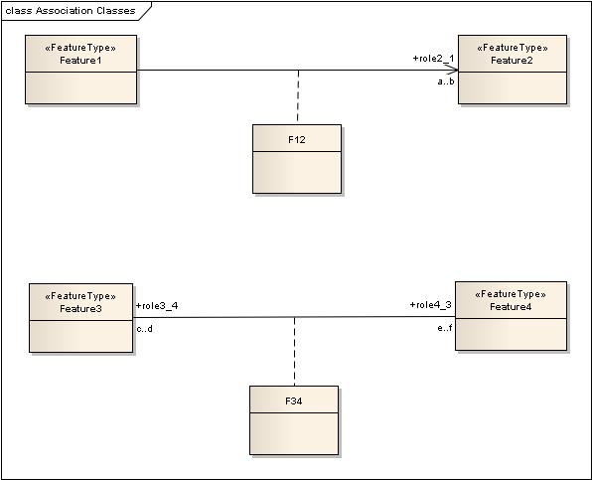
Figure 10b-2 – Model with association classes (from OGC 10-129r1 / ISO 19136-2:2015)

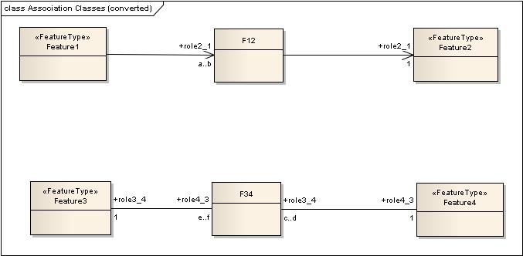
Figure 10b-3 – Model after conversion of association classes (from OGC 10-129r1 / ISO 19136-2:2015)

Data types

Primitive types
The S-100 GML Profile supports the primitive types defined in § 1-4.5.2:
- Boolean
- Integer
- Real
- CharacterString
- Date
- Time
- DateTime
- S100_TruncatedDate
- URI, URN, URL
Types may be supported using XML Schema built-in data types.

Value types
The S-100 GML Profile supports the value types defined in § 1-4.5.3.5:
- Measure
- Length
- Angle
NOTE: S100_UnitsOfMeasure type shall be realised by the uom property, the value of which should reference to a value defined in a codelist register which provides the name, definition and symbol.

Other data types
Application schemas describing data formats for data products may make use of built-in data types defined in “W3C XML Schema: Part 2” and additional data types to be defined within the GML Application Schema.
Example: The GML application schema encapsulating a data format may support the S-100 data type URI using the XML schema built-in type anyURI and S100_TruncatedDate using one or more of the XML Schema built-in types gYear, gMonthDay, gDay, gYearMonth, gMonthDay, as governed by the product specification.

Spatial types

Geometric primitives
The S-100 GML Profile supports the GML 3.2.1 encodings of basic geometries (§ 7-5.1):
- Point
- AbstractCurve
- Curve
- OrientableCurve
- LineStringSegment
- Surface
- LineString
- Polygon
- S100_ArcByCenterPoint
- S100_CircleByCenterPoint
The S-100 GML Profile constrains the GM_CurveInterpolation type values and constrains the curve encoding to a subset of GML curve geometries.
Note: S100_ArcByCenterPoint and S100_CircleByCenterPoint are not the same as the GML primitives ArcByCenterPoint and CircleByCenterPoint.

Curve Interpolation
The list of allowable values consists of a subset of the values allowed by ISO 19136 plus extensions for spline and interpolated curve segments (the forthcoming new edition of ISO 19107 clarifies that the list of interpolations in the standard is not exhaustive):
- Linear (linear) in a non-geographic CRS – the interpolation is defined by a series of DirectPositions on a straight line between each consecutive pair of controlPoints.
- Linear interpolation (linear) in a geographic CRS (interpreted as Loxodromic) – the interpolation method shall return DirectPositions on a loxodromic curve between each consecutive pair of controlPoints. A loxodrome is a line crossing all meridians at the same angle, that is, a path of constant bearing.
- Geodesic (geodesic) – the interpolation mechanism shall return DirectPositions on a geodesic curve between each consecutive pair of controlPoints. A geodesic curve is a curve of shortest length. The geodesic shall be determined in the coordinate reference system of the GM_Curve in which the GM_CurveSegment is used.
- Circular arc by 3 points (circularArc3Points) – the interpolation is defined by a series of 3 DirectPositions on a circular arc passing from the start point through the middle point to the end point for each set of three consecutive control points. The middle point is located halfway between the start and end point.
- Elliptical arc (elliptical) – for each set of four consecutive controlPoints, the interpolation mechanism shall return DirectPositions on an elliptical arc passing from the first controlPoint through the middle controlPoints in order to the fourth controlPoint. Note: if the four controlPoints are co-linear, the arc becomes a straight line. If the four controlPoints are on the same circle, the arc becomes a circular one.
- Conic arc (conic) – the same as elliptical arc but using five consecutive points to determina a conic section.
- Circular arc with centre and radius (circularArcCenterPointWithRadius) – the interpolation is defined by an arc of a circle of the specified radius centred at the position given by the single control point. The arc starts,at the start angle parameter and extends for the angle given by the angular distance parameter. This interpolation type shall be used only with S100_ArcByCenterPoint and S100_CircleByCenterPoint geometry. The precise semantics of the parameters are defined in Part 7 clause 7-5.2.20 (S100_ArcByCenterPoint).
- Polynomial (polynomialSpline) – the control points are ordered as in a line-string, but they are spanned by a polynomial function. Normally, the degree of continuity is determined by the degree of the polynomials chosen.
- Bézier Spline (bezierSpline) – the data are ordered as in a line string, but they are spanned by a polynomial or spline function defined using the Bézier basis. Normally, the degree of continuity is determined by the degree of the polynomials chosen.
- B-spline (bSpline) – the control points are ordered as in a line string, but they are spanned by a polynomial or rational (quotient of polynomials) spline function defined using the B-spline basis functions (which are piecewise polynomials). The use of a rational function is determined by the Boolean flag "isRational." If isRational is TRUE then all the DirectPositions associated with the control points are in homogeneous form. Normally, the degree of continuity is determined by the degree of the polynomials chosen.
- Blended parabolic (blendedParabolic) – the control points are ordered as in a line-string, but are spanned by a function that blends segments of parabolic curves defined by triplet sequences of successive data points. Each triplet includes the final two points of its predecessor. Further details of the semantics are provided in Part 7 clause 7-4.2.2.2.

Geometric complex, geometric composites, and geometric aggregates

Geometric complex and geometric composites
The S-100 GML Profile supports the following composite geometries (§ 7-5.1):
- CompositeCurve.

Geometric aggregates
The S-100 GML Profile supports the aggregate geometry types (§ 7-5.1):
- MultiPoint

Inline and by-reference encoding
The S-100 GML Profile supports the ability to encode a geometry either inline or by reference where two features share the same instance of a GM_Object (see § 3-6.5.4.5).

Envelope
The S-100 GML Profile supports the ability to encode an appropriate geometry via bounding box or envelope. The Profile does not constrain the use of the GML implementation of GM_Envelope.

Unsupported GML functionality
Support for GML 3.2.1 and GML 3.3 geometries not defined in ISO 19107 is not included. Specifically, this means CircleByCenterPoint and ArcByCenterPoint (as defined in GML 3.2.1) are not supported, nor are the compact geometry encodings defined in GML 3.3. S-100 Edition 2.0.0 provides different definitions for arc and circles by center point and radius.
The temporal model and temporal primitives defined in ISO 19108, including temporal positions, instants, time periods, are not supported. S-100 data should code dates and times as thematic attributes.
Dynamic features are not supported by the S-100 GML profile.
Topology is not supported by the S-100 GML profile.
Linear Referencing is not supported by the S-100 GML profile.
Coverages are not supported by the S-100 GML profile.
The ability to define coordinate reference systems is not supported. The products should be defined using a well-known, pre-defined coordinate reference system such as WGS84.
Observations are out of scope for the S-100 GML Profile. (The observations schema within GML has been superseded by the OGC (10-025r1) XML encoding for ISO 19156: Observations and Measurements.)

Compliance levels
In order for a client to be able to properly interpret a schema, it needs a capability to identify the compliance level of the application schema. An XML Schema annotation shall be used for this purpose. The following schema fragment shows how this annotation shall be declared in an application schema:
<annotation>
<appinfo>
<gmlProfileSchema xmlns="http://www.opengis.net/gml/3.2">
http://www.iho.int/S-100/profiles/s100_GMLProfile.xsd
</gmlProfileSchema>
<s100:ComplianceLevel>1</s100:ComplianceLevel>
</appinfo>
</annotation>
Figure 10b-4 – Compliance declaration XML code

Compliance level | Description
1 | S-100 feature types, information types, feature and information associations. Point, curve, and surface primitives
2 | All features of Level 1, plus circle and arc by center point geometry, splines, and blended interpolations

To manually add the compliance declaration to the schemas after they have been generated involves 3 steps:
- Add the S-100 GML Profile XML Namespace declaration:
xmlns:s100_profile="http://www.iho.int/S-100/profile/s100_gmlProfile"
- Add the S-100 GML Profile compliance declaration within the schema annotation. The compliance declaration is the XML code in Figure 10b-4 above.
- Add an Import statement for the S-100 GML Profile Levels schema. Add the following import statement for the S-100 GML Profile Levels schema into the list of imported schemas to the list of imported schemas:
<import namespace="http://www.iho.int/S-100/profile/s100_gmlProfile"
schemaLocation="../../S100/profile/S100_gmlProfileLevels.xsd"/>

S-100 base schema for feature data

Introduction
A second XML schema is provided which defines a small set of derived types and elements in an “S100” namespace. The schema defining these common elements and types is technically a “GML application schema” in the sense defined by ISO 19136. It defines GML constructs which are expected to be used by different product specifications to define detailed GML application schemas encoding formats for GML datasets. This schema provides a common core structural paradigm for GML datasets across a variety of application domains. The intention is to reduce the complexity of application development, facilitate sharing of software modules, and information integration and mapping across different application domains, by minimising the proliferation of structural variations.
Elements and types are defined using the restricted subset of GML defined in the S-100 GML Profile.

Features
An XML complex type AbstractFeatureType is defined as the base types for features. The AbstractFeatureType extends the gml:AbstractFeatureType as defined in the S-100 GML Profile by adding feature object identifier (§ 10b-9.7) and associations to feature and information objects (§ 10b-9.5). An inverse feature association is also included to allow reverse pointers for feature associations.
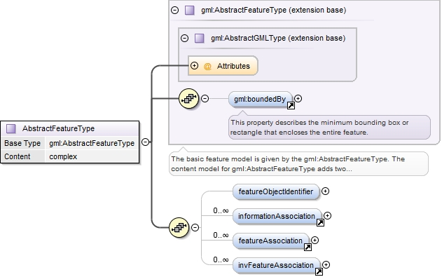
Figure 10b-5 – Base type definition for S-100 feature elements

Information types
The common type defintion for information types is similar to that for the common feature type, but omits the feature object identifier and feature associations.
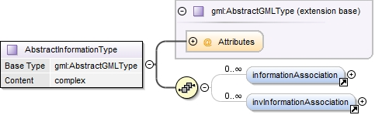
Figure 10b-6 – Base type definition for S-100 information type elements

Spatial types
Spatial types are defined as extensions of the corresponding GML spatial types with an information association added, since in S-100 spatial objects can have information associations. The figure below shows the design of the Point type in the S-100 schema. It includes a single gml:Point type and 0 or more associations to S-100 information types.
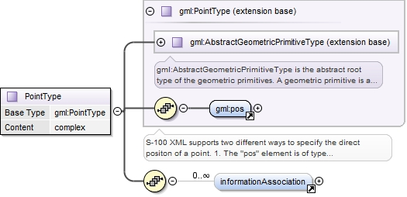
Figure 10b-7 – S-100 generic S-100 spatial type for point spatial object
The other spatial types have a similar structure.

Inline and referenced geometry
The base schema also allows geometry to be defined either inline or by reference, conforming with the same ability in GML.

Spatial types defined in base schema
The base schema defines the point, curve, and surface spatial objects, as well as multipoint and composite curve objects. Curves may be simple, composite, or orientable curves. This is the same set defined in the S-100 GML profile (§ 10b-8.5). It also supports gml:Polygon (ISO 19136) which is a special surface that is defined by a single surface patch.
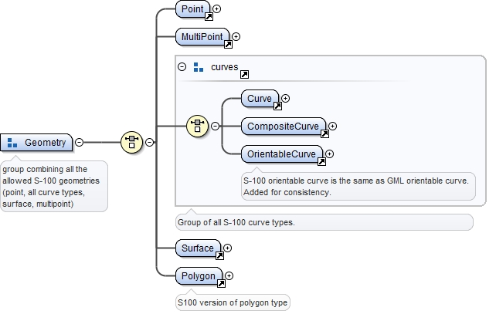
Figure 10b-8 – Geometry types defined in the base schema

Associations
Feature and information association properties are defined as extensions of GML feature properties. The pointers to the object at the other end of the association are encoded in the Xlink attributes.
XLink components are the standard method to support hypertext referencing in XML. GML provides an XML Schema attribute group, gml:AssociationAttributeGroup, to support the use of Xlinks as the method for indicating the value of a property by reference in a uniform manner in GML. ISO 19136 specifies that the value of a GML property that carries an xlink:href attribute is the resource returned by traversing the link.
The data types of the attributes are listed in the table below.
Table 10b-1. Requirements for XLink attributes in associations
Xlink attribute | Data type | Remarks
href | URI | Reference to the object at the other end of the association, for example, the gml:id of an object in the current data set. May be a URI fragment.as described in the XLink specification
role | URI | Optional description of the nature of the target resource, given as a URI
arcrole | legacy extended IRI | Description of the role or purpose of the target resource in relation to the present resource, given as a URI (ISO 19136). May be constructed from the role name from the application schema.  The XLink 1.1 specification requires:  1) The value must be a Legacy extended IRI  2) The identifier must not be relative
title | character string | Optional string describing the relationship. Product specifications may constrain its format and define its semantics
show |  | not used
actuate |  | not used
type |  | not used

Product specifications may use one of the two methods described in the following sub-clauses to encode associations. Consistent use of a single method for each data product is strongly recommended.

Generic tags for associations
The profile defines two generic tags for feature and information associations, depicted in the figures below.

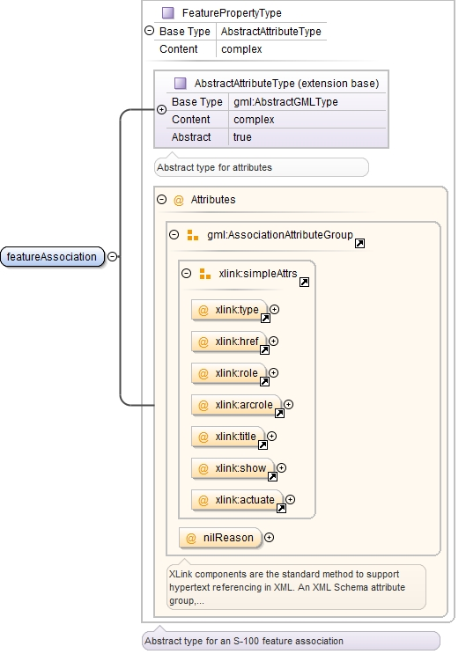
Figure 10b-9 – S-100 type for feature association
Information associations have a structure similar to feature associations except that they are information properties.
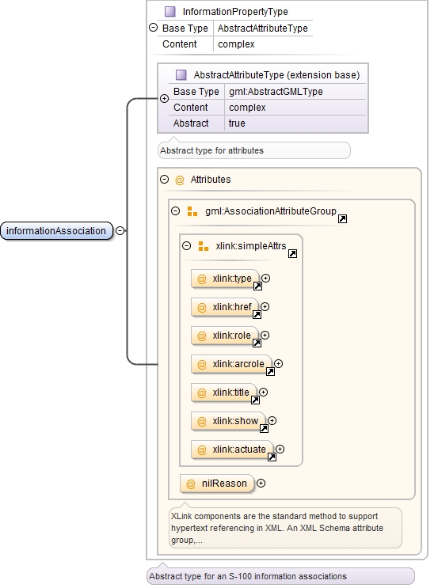
Figure 10b-10 – S-100 type for information association
Example (non-normative): Given the XML fragments below, the MarineProtectedArea feature has an information association to the Regulations information object.

<MarineProtectedArea gml:id=“US123450”
<informationAssociation xlink:href=”#US50004”
xlink:arcrole=”http://www.iho.int/S-122/roles/theRegulations”/>
...
</MarineProtectedArea>

and elsewhere in the same file:
<Regulations gml:id=”US50004”>
...
</Regulations>

Role name as property element
Alternatively, the roles defined in the application schema may be used as a property element of the feature or information type, with XLink attributes providing the reference to the instance. In this case the role at the far end of the association should be used for the XML tag defining the property. The role name may be usable as-is for the property tag, or it may have to be mapped to a tag conforming to XML and GML conventions.
Example (non-normative): Given an application schema containing the relationship in the figure below, the NavigationLine feature can encode the association as a property element named navTrack as below. The format, construction rules, and semantics for the arcrole and title values would be defined in the product specification.
<NavigationLine gml:id=”US123098”>
<navTrack xlink:href=”#US890321”
xlink:arcrole=”urn:iho:s101:1.0:52.2” title=”RangeSystem”/>
...
</NavigationLine>

and elsewhere in the same file:
<RecommendedTrack gml:id=”US890321”>
<navLine xlink:href=”#US123098”
xlink:arcrole=”urn:iho:s101:1.0:52.1” title=”RangeSystem”/>
...
</RecommendedTrack>

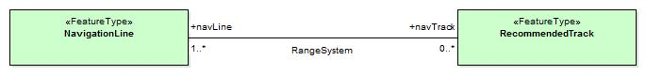
Figure 10b-11 – Association in application schema

Dataset general information

Dataset identification
Dataset identification information is defined by the complex type DatasetIdentificationType. The fields are shown in the table and figure below.
Table 10b-2. Dataset identification header elements
Field | XML Tag | Value | Mult. | Type | Description
Encoding specification | encodingSpecification | ‘S-100 Part 10b’ | 1 | CharacterString | Encoding specification that defines the encoding
Encoding specification edition | encodingSpecificationEdition | “1.0” | 1 | CharacterString | Edition of the encoding specification
Product identifier | productIdentifier |  | 1 | CharacterString | Unique identifier for the data product
Product edition | productEdition |  | 1 | CharacterString | Edition of the product specification
Application profile | applicationProfile |  | 1 | CharacterString | “1” – base datasets  “2” – update datasets
Dataset file identifier | datasetFileIdentifier |  | 1 | CharacterString | The file name including the extension but excluding any path information
Dataset title | datasetTitle |  | 1 | CharacterString | The title of the dataset
Dataset reference date | datasetReferenceDate |  | 1 | date | The issue date of the dataset.  Format: YYYY-MM-DD
Dataset language | datasetLanguage | “EN” | 1 | ISO 639-1 | The (primary) language used in this dataset
Dataset abstract | datasetAbstract |  | 0..1 | CharacterString | The abstract of the dataset
Dataset topic category | datasetTopicCategory | {14}{18} | 1..* | MD_TopicCategoryCode (ISO 19115) | A set of topic category codes from the MD_TopicCategoryCode list in ISO 19115

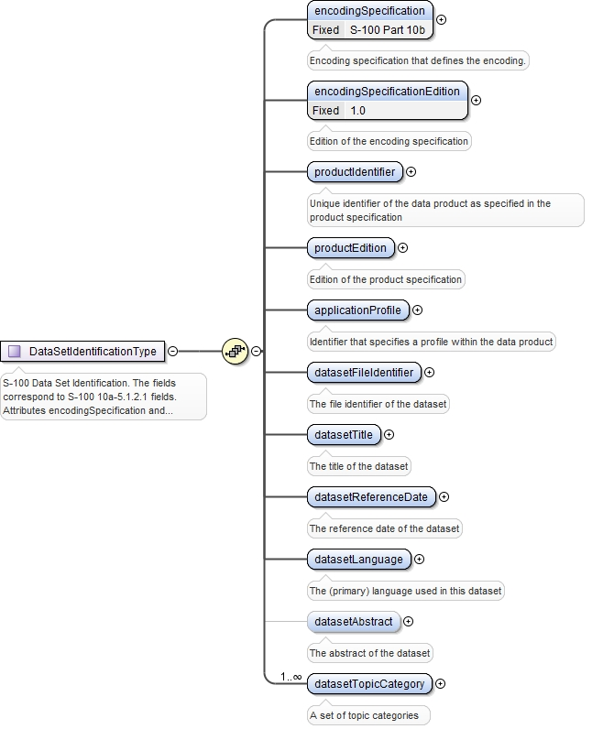
Figure 10b-12 – Dataset identification

Dataset structure information
Dataset structure information is defined by the complex type DatasetStructureInformationType. The fields are shown in the table and figure below.
Table 10b-3. Dataset identification header elements
Subfield name | XML Tag | Default Value | Mult. | Type | Description
Dataset Coordinate Origin X | datasetCoordOriginX | 0.0 | 0..1 | Real | Shift used to adjust x-coordinate before encoding. Set to 0.0 if no shift is used.
Dataset Coordinate Origin Y | datasetCoordOriginY | 0.0 | 0..1 | Real | Shift used to adjust y-coordinate before encoding. Set to 0.0 if no shift is used.
Dataset Coordinate Origin Z | datasetCoordOriginZ | 0.0 | 0..1 | Real | Shift used to adjust z-coordinate before encoding.
Coordinate multiplication factor for x-coordinate | coordMultFactorX | 1 | 0..1 | Positive Integer | Floating point to integer multiplication factor for the x-coordinate or longitude.
Coordinate multiplication factor for y-coordinate | coordMultFactorY | 1 | 0..1 | Positive Integer | Floating point to integer multiplication factor for the x-coordinate or longitude.
Coordinate multiplication factor for z-coordinate | coordMultFactorZ | 1 | 0..1 | Positive Integer | Floating point to integer multiplication factor for the z-coordinate or depths or height.
Number of Information Type records | nInfoRec |  | 0..1 | Integer ≥ 0 | Number of information records in the dataset.
Number of Point records | nPointRec |  | 0..1 | Integer ≥ 0 | Number of point records in the dataset.
Number of Multi Point records | nMultiPointRec |  | 0..1 | Integer ≥ 0 | Number of multi point records in the dataset.
Number of Curve records | nCurveRec |  | 0..1 | Integer ≥ 0 | Number of curve records in the dataset.
Number of Composite Curve records | nCompositeCurveRec |  | 0..1 | Integer ≥ 0 | Number of composite curve records in the dataset.
Number of Surface records | nSurfaceRec |  | 0..1 | Integer ≥ 0 | Number of surface records in the dataset.
Number of Feature Type records | nFeatureRec |  | 0..1 | Integer ≥ 0 | Number of feature records in the dataset

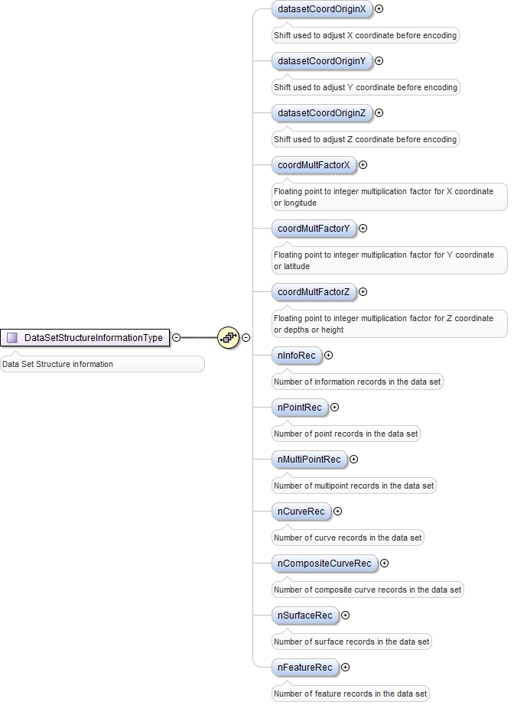
Figure 10b-13 – Dataset structure information

Feature object identifier
The S-100 base schema provides a definition of feature object identifier structured similarly to the feature object identifier of S-57 Ed. 3.1.
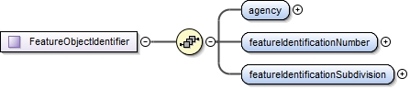
Figure 10b-14 – Structure of feature object identifier element

Coordinate Reference System
GML allows the coordinate reference system (“spatial reference system”) used for geometry to be determined in different ways – by explicit specification, or by “inheriting” the SRS of outer elements. For S-100 datasets, this means the SRS can be specified in one of two ways:
- Using the srsName attribute of the gml:Envelope element in a feature collection implies that the same SRS is uses for all geometries contained in that collection.
- Using the srsName and srsDimension attributes for individual geometry elements.
Application data formats may use either method, but shall ensure that the SRS of every instance of geometry in a dataset can be determined by application software, using one method or another.
“Standard” geodetic coordinate reference systems shall be identified using the URI convention for SRS specified by OGC.
Example: http://www.opengis.net/def/crs/EPSG/0/4326

Dataset structure definition
Application schemas for data products shall define an XML type and element to serve as the root element of a GML dataset, consisting of a collection of XML elements for feature, information type, and spatial data objects defined elsewhere in the application schema.

Dataset metadata
The dataset class may contain one or metadata properties to encode dataset level metadata (for example ISO 19115/19139) either inline or by reference.

Constraints and validation
Some validation of data can be done using validating XML processors if the data product’s GML application schema created well defined types wherever possible, for example, enumerated types for the enumeration attributes, and maximum and minimum allowed values for real attributes. However, complete validation, especially of conditional attributes, is likely to require an additional means of data validation.
Constraints allow complex business rules to be defined that restrict the allowable values based on well-defined limits or relationships between properties (for example the end date must be equal to or greater than the start time).
Constraints can be defined in many different ways - human readable text only, object constraint language (OCL), Semantics of Business Vocabulary and Business Rules (SVBR) and these can be documented as part of the UML model or external to the model.
The S-100 GML Profile does not provide explicit support for expressing constraints or for rule-based validation. Current industry best practice, advocates the uses of Schematron to validate XML files based against business rules defined using OCL, SVBR or human readable text. Schematron (ISO/IEC 19757-3) is a rule-based validation language for making assertions about the presence or absence of patterns in XML. Constraints encoded using Schematron may be directly encoded within the resulting Application Schema or may be defined in an associated Schematron document.

Dataset level metadata and integrity checks
The S-100 GML Profile does not explicitly contain any elements relating to dataset level metadata or integrity checks. These should be defined within an S-100 Application Schema as properties of the Feature Collection class.
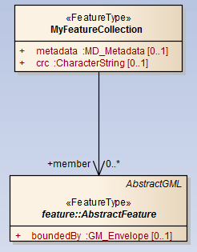
Figure 10b-15 – Encoding dataset metadata and integrity check properties

Schema locations and namespaces
The GML profile and GML application schema for common elements are located at the IHO GI registry web site. Namespaces and versions are also defined on that site.

Divergences from common GML practices
The GML profile (10b-8) and base schema (10b-9) diverge from common GML practice in the following items:
- Interpretation of missing curve interpolation value (§§ 10b-7.2, 10b-8.5.2).
- Allowing feature and information associations to use one of two standard properties <featureAssociation> and <informationAssociation> instead of the role name as the property name. The values XLink attributes in associations are specified as described in this Part which overrides the interpretations in the XLink specification.
- Geometry properties are defined individually instead of using substitution groups. There is no single property which functions as a spatial attribute in all features.

Conventions for S-100 GML data formats
Data formats must use the camel case codes of features, information types, and attributes as specified in feature catalogues as the ‘local name’ in element tags for GML features, objects, or attributes.
EXAMPLE: Given a feature catalogue that defines a feature named “Marine Protected Area” with code “MarineProtectedArea” the corresponding feature in the dataset must use “MarineProtectedArea” as the local name – e.g., <S122:MarineProtectedArea ... or <MarineProtectedArea ... .
For S-100 Enumeration or S-100 Codelist attributes, datasets must use the code, label, or alias field of the listed value as encoded in the feature catalogue. Dataset header information must specify which is used in the attributeEncoding field of header metadata.
Spatial objects that are encoded independently of features (i.e., not embedded in a feature) must be encoded with tags whose local name components are the spatial object elements in the S-100 GML profile (e.g., S100:Point).
Feature and information associations must encode at least one of the role or arcrole attributes of the reference.
The following tags are reserved and may not be used in GML data formats as local names of elements:
- member
- imember
- geometry
- location
GML data formats for S-100 datasets must follow the GML rules as described in the GML specification (ISO 19136/OGC 07-036), as modified by the S-100 GML profile and this Part.

Processing of GML datasets (informative)
Implementations, including applications and production tools, may use any suitable method for processing GML datasets. While GML datasets must conform to the GML application schemas defined in product specifications, processors are not required to use the GML application schemas for processing datasets. However, the combination of the GML specification, this Part, and the S-100 GML profile result in the following commonalities:
- Each dataset has a single root element (“ROOTELEMENT”). GML datasets are XML documents and this is an XML requirement.
- The tags “member” and “imember” are reserved for use as wrapper tags for feature and information types. Use of these wrapper tags is optional in S-100 GML application schemas.
- Given the path /ROOTELEMENT/member/X1/X2 then X1 is a feature and X2 is an attribute or association role. Similarly given /ROOTELEMENT/imember/X1/X2 X1 is an information type and X2 one of its attributes or associations.
- If X2 has XML attributes xlink:href and xlink:role and/or xlink:arcrole it is an association role.
- If X2 has element content it is a complex or spatial attribute.
- A spatial attribute or object will have one of the allowed spatial properties as its content.
- If X2 is empty and nilled, or has text or numeric content, it is a simple attribute.
- Applications must allow for the presence or absence of namespaces, e.g. X1 might be of the form S122:FeatureA, etc. Namespaces in XML precede a ':' so it is possible for applications to distinguish the namespace part of the tag from the ‘local name’ part.

Appendix 10b-A Application Schema (informative)

Example of a GML application schema for an S-100-based data product
The example schema defines abstract base types for features and information types in the data product. Attributes common to all features/information types can be defined here. The abstract elements act as substitution group heads for feature and information type instances. This is convenient especially if the number of features or information type definitions is relatively high. GML also requires that features in GML application schemas be in the substitution group of gml:AbstractFeature and this can be achieved using the substitution groups.
<!-- base types for all features in this data product -->
<xs:complexType name="AbstractFeatureType">
<xs:complexContent>
<xs:extension base="s100:AbstractFeatureType">
<xs:sequence>
<xs:element name="scaleMinimum" type="xs:positiveInteger"/>
</xs:sequence>
</xs:extension>
</xs:complexContent>
</xs:complexType>

<xs:element name="AbstractFeature" type="AbstractFeatureType"
abstract="true" substitutionGroup="gml:AbstractFeature">
<xs:annotation>
<xs:documentation>Substitution group head for features</xs:documentation>
</xs:annotation>
</xs:element>

<!-- base types for all information types in this data product -->
<xs:complexType name="AbstractInformationTypeType">
<xs:complexContent>
<xs:extension base="s100:AbstractInformationType">
<xs:sequence/>
</xs:extension>
</xs:complexContent>
</xs:complexType>
<xs:element name="AbstractInformationType" type="AbstractInformationTypeType"
abstract="true" substitutionGroup="gml:AbstractGML">
<xs:annotation>
<xs:documentation>Substitution group head for information objects</xs:documentation>
</xs:annotation>
</xs:element>
Figure 10b-A-1 – Base abstract types and elements in GML application schema
The figure below is a graphical representation of the model of AbstractFeatureType, defined above, showing the inherited feature identifier element, inherited association elements for feature and information associations, as well as the locally defined attribute scaleMinimum.
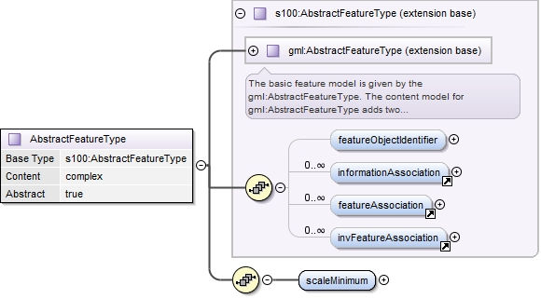
Figure 10b-A-2 – Hierarchy of abstract types for features in GML application schema
Information types are derived from the base type. The example has a single information type named ChartNote. Attributes specific to the information type are defined here.
<xs:complexType name="ChartNoteType">
<xs:complexContent>
<xs:extension base="AbstractInformationTypeType">
<xs:sequence>
<xs:element name="text" type="xs:string"/>
</xs:sequence>
</xs:extension>
</xs:complexContent>
</xs:complexType>

<xs:element name="chartNote" type="ChartNoteType"
substitutionGroup="AbstractInformationType">
<xs:annotation>
<xs:documentation>A chart note conveys information in plain text.</xs:documentation>
</xs:annotation>
</xs:element>
Figure 10b-A-3 – Information type definition
The definition of feature classes is similar, except that they derive from AbstractFeatureType and include spatial attributes.
Since this data product requires alternative types of spatial properties for some feature classes (hat is, the LandArea feature can have either point or area geometry), geometry is defined as a choice element offering either point or surface property).
Note that the GML specification states that geometry properties shall have application-specific names which express the semantics:
Application-specific names shall be chosen for geometry properties in GML application schemas. The names of the properties should be chosen to express the semantics of the value. Using application specific names is the preferred method for names of properties including geometry properties.
There are no inherent restrictions in the type of geometry property a feature type may have as long as the property value is a geometry object substitutable for gml:AbstractGeometry.
This profile therefore allows spatial attributes be implemented using geometry substitution groups or element names with application-specific semantics. The schema includes predefined property types which may be used as types of geometry property elements. However GML application schema developers should keep in mind the relevant requirements for stated in ISO 19136, for example, in clause 10.1.3.1 about derivation from gml:AbstractGeometryType and substition groups for geometry.
<!-- feature definitions -->
<xs:complexType name="DepthAreaType">
<xs:complexContent>
<xs:extension base="AbstractFeatureType">
<xs:sequence>
<xs:element name="depthValue1" type="xs:double"/>
<xs:element name="depthValue2" type="xs:double"/>
<xs:element ref="s100:surfaceProperty"/>
</xs:sequence>
</xs:extension>
</xs:complexContent>
</xs:complexType>

<xs:element name="depthArea" type="DepthAreaType"
substitutionGroup="AbstractFeature"/>

<xs:complexType name="LandAreaType">
<xs:annotation>
<xs:documentation>One of the features in this data product is LandArea</xs:documentation>
</xs:annotation>
<xs:complexContent>
<xs:extension base="AbstractFeatureType">
<xs:sequence>
<xs:element name="objectName" type="xs:string"/>
<xs:choice>
<xs:element ref="s100:pointProperty"/>
<xs:element ref="s100:surfaceProperty"/>
</xs:choice>
</xs:sequence>
</xs:extension>
</xs:complexContent>
</xs:complexType>

<xs:element name="landArea" type="LandAreaType"
substitutionGroup="AbstractFeature"/>
Figure 10b-A-4 – Feature class definition
The example also defines an XML type for datasets and convenience groups collecting features and information types for use in the dataset definition. Developers of GML application schemas should keep in mind the rules for GML application schemas in § 20 of ISO 19136.
The figure below shows a graphical representation of the DepthArea feature defined above, showing the components inherited from the abstract feature hierarchy and locally defined thematic attributes and allowed spatial attribute. The abstract type defined above is extended by adding the thematic attributes bound to the feature class and also the appropriate spatial attribute(s). A feature class may have different types of spatial objects associated with it, this can be represented using appropriate XML <choice> constructs.
Example: A feature may have either Point or Surface geometry but not curve geometry. This is represented by an XML <choice> particle containing point or surface property types but none of the curve types.
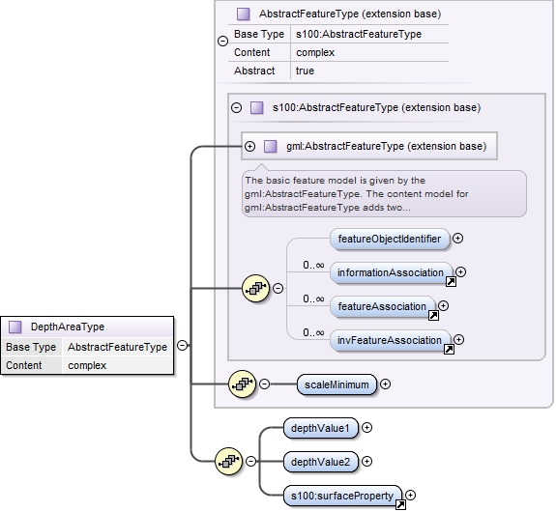
Figure 10b-A-5 – Type hierarchy of feature class in GML application schema

Appendix 10b-B

Use of Profile in GML Application Dataset

(informative)

Introduction
This clause illustrates the use of the GML profile (10b-8) and base schema (10b-9) and a GML application schema (App. 10b-A) for an S-100-based data product and a GML dataset.

Dataset structure in GML application schema
An example of the format of a GML dataset is shown in the figure below. This dataset defines data objects as information objects, spatial objects. or feature objects. It specifies the sequence of objects in the file as information objects first, followed by spatial objects, then features.
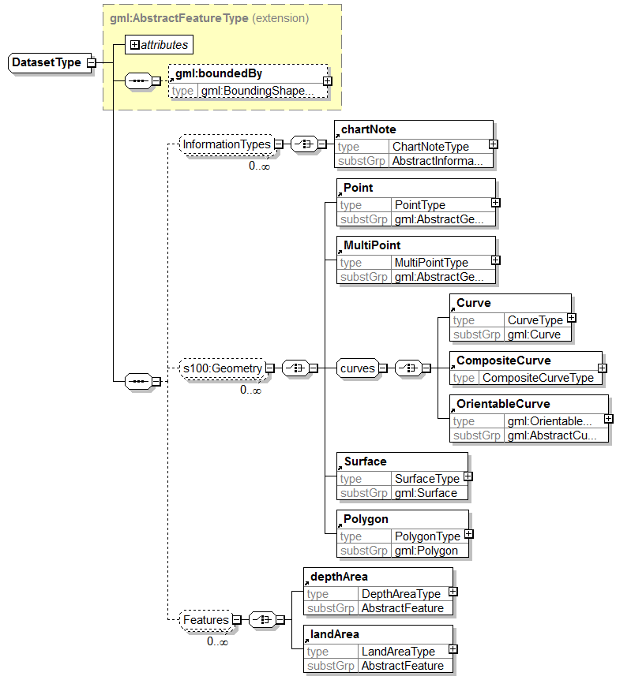
Figure 10b-B-1 – Example of dataset definition in GML application schema

Dataset examples in XML/GML
The figure below shows a partial example dataset. Content in italics has been omitted for brevity.
<Dataset (... namespaces and schemaLocation ...) gml:id="ds">

<gml:boundedBy>
<gml:Envelope srsName="http://www.opengis.net/def/crs/EPSG/0/4326">
<gml:lowerCorner>0.0 0.0</gml:lowerCorner>
<gml:upperCorner>3.0 3.0</gml:upperCorner>
</gml:Envelope>
</gml:boundedBy>

<!-- information objects -->
<chartNote gml:id="cn1">
<text>The reporting area does not include the Areas to be Avoided within the Monument.</text>
</chartNote>

<chartNote gml:id="cn2">
<text>Vessels shall notify the authority when leaving the reporting area to enter an Area to be Avoided.</text>
</chartNote>

<!-- spatial objects -->
<s100:Curve gml:id="curve1">... geometry of curve1 ...</s100:Curve>
<s100:Curve gml:id="curve2">... geometry of curve2 ...</s100:Curve>
<!-- curve3 references curve2 -->
<s100:OrientableCurve gml:id="curve3" orientation="-">
<gml:baseCurve xlink:href="#curve2"/>
</s100:OrientableCurve>

<!-- this surface uses curve1 as boundary -->
<s100:Surface gml:id="su1">
<gml:patches>
<gml:PolygonPatch>
<gml:exterior>
<gml:Ring>
<gml:curveMember xlink:href="#curve1"/>
</gml:Ring>
</gml:exterior>
</gml:PolygonPatch>
</gml:patches>
</s100:Surface>

<s100:Surface gml:id="su2">... geometry of surface su2 ...</s100:Surface>

<!-- features -->
<depthArea gml:id="da1">
<s100:featureObjectIdentifier>
<s100:agency>JS</s100:agency>
<s100:featureIdentificationNumber>123</s100:featureIdentificationNumber>
<s100:featureIdentificationSubdivision>345</s100:featureIdentificationSubdivision>
</s100:featureObjectIdentifier>
<scaleMinimum>10000</scaleMinimum>
<depthValue1>1.0</depthValue1><!-- thematic attribute -->
<depthValue2>6.0</depthValue2><!-- thematic attribute -->

<!-- the geometry here is given by reference to surface su1 above -->
<s100:surfaceProperty xlink:href="#su1"/><!-- example of geometry reference -->
</depthArea>

<depthArea gml:id="da2">
<s100:featureObjectIdentifier>
<s100:agency>JS</s100:agency>
<s100:featureIdentificationNumber>123</s100:featureIdentificationNumber>
<s100:featureIdentificationSubdivision>345</s100:featureIdentificationSubdivision>
</s100:featureObjectIdentifier>

<!-- association to the first information object above, identified by its gml:id in
the xlink:href attribute -->
<s100:informationAssociation gml:id="ia2"
xlink:href="#cn1"
xlink:arcrole="http://example.iho.int/roles/hasNote"/>

<!-- feature association to a depth area feature, identified by xlink:href -->
<s100:featureAssociation gml:id="fa1"
xlink:href="#da1"
xlink:arcrole="http://example.iho.int/roles/rolea"/>

<scaleMinimum>10000</scaleMinimum>
<depthValue1>1.0</depthValue1>
<depthValue2>6.0</depthValue2>

<!-- geometry is given by reference -->
<s100:surfaceProperty xlink:href="#su2"/>
</depthArea>

<landArea gml:id="la1">
<scaleMinimum>10000</scaleMinimum>
<objectName>Micklefirth City</objectName>
<s100:pointProperty>
<!-- inline geometry - directposition -->
<s100:Point gml:id="pnt1">
<gml:pos>1.5 1.5</gml:pos>
</s100:Point>
</s100:pointProperty>
</landArea>

</Dataset>
Figure 10b-B-2 – Example GML dataset

Page intentionally left blank

Line breaks and spaces have been added for clarity.

